Crash
Reconstruction
Unit
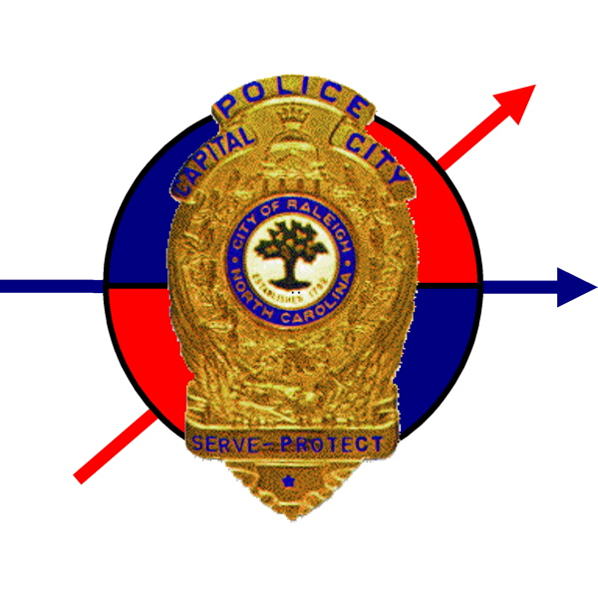
Field Book

Date: ______________________ Time: ____________
Location: __________________________District: ______
Case Number: ___________________________

Officer: _______________________Code: ___________
REMEMBER THESE RULES !

- Make sure that the units in this guide match the units on the DMV report (once Unit One, always unit One). Remember, if a City vehicle is involved, it MUST BE UNIT ONE.!!

- Regarding evidence: locate, identify, photograph, mark, measure. In that order.

- Always collect very-short term evidence (impairment, anti-lock brake skids, weather conditions), then short term evidence (tire marks, injuries) then long term evidence (gouges, dimensions of roadway, most vehicle data).

- Never power up a vehicle after a crash. This can destroy light bulb evidence and event data recorder information.

- Put a hold on towed vehicles until they have been examined away from the scene.

- If it is a nighttime crash, go back in the daytime to re-examine the scene. If possible, hold the scene until daylight.

This Field Book was developed by the Raleigh, NC P.D.
You can edit it to meet your own needs.

Table of Contents
Section |  | Assigned To:

DMV – 349 Report

General Information (p3-4)
Environment / Roadway (p5)
Measurements (coordinate) (p6)
Field Sketch (p7)
Measurements (general) (p8-10)

Vehicle # ____ (p11-18)

Vehicle # ____ (p19-26)

Driver/Ped # ____ (p27-30)

Driver/Ped # ____ (p31-34)
Occupant Vehicle # ___ (p35-38)
Occupant Vehicle # ___ (p39-42)
Occupant Vehicle # ___ (p43-46)
Occupant Vehicle # ___ (p47-50)
Witnesses (p51-54)

Appendices
Voluntary Statement Forms
Rights Form
Driving While Impaired Reports
DWI Blood Search Warrant
Search Warrant Inventory
Unusual vehicle crashes |  | Inside back cover
Other tasks |  | Assigned to

Phone numbers

General Information
Police Responders
Role | Name / District | Contact Number
Lead TCI
Secondary TCI
Secondary TCI
Secondary TCI
Secondary TCI
First responding officer
On-scene supervisor
On-scene supervisor
Other Responders
Agency / Unit | Name | Contact Number
Example: EMS 4 | John Doe / Susie Smith | 555-1212
Number of units involved: ________ injuries: ________ fatalities: ________

Crash Reconstruction Sergeant notified by: ___________________________________

Medical Examiner: ______________________________________________________
ME notified by: _________________________________________________________
Next of Kin notification assigned to: _________________________________________
(see driver / occupant sheets for specific next of kin information)

Assistant District Attorney:_________________________________________________
District Attorney’s Office notified by: _________________________________________

Notes / Summary:
Environment

The crash occurred on _______________________________. The roadway surface is _______________________(asphalt, concrete, etc) and the surface was _______________________________ (wet, dry, debris, etc) at the time of the crash. The speed limit on the roadway is ______ and signs are posted _____ feet N S E W and ________ feet N S E W from the crash scene. Photos have / have not been taken of the speed limit signs. The weather at the time of the crash was _______________ (clear, rainy, etc) and the temperature was about ______ F°. The following traffic control device was present at the time of the crash: ___________________________. It did / did not appear to have been working normally at the time of the crash. The roadway was lighted by ____________________ (sun, street lights, nothing). The scene was photographed by _______________________.

Notes / Summary of Environment:
Scene Measurements
Label | X direction  (along baseline) | Y direction  (from baseline) | Description

Field Sketch
Measurements (General)

Distance from cross street? _______ feet N S E W from ________________________.

Any possible environmental vision obstructions? Yes / No

Drag Factor Data

Describe how drag factor was obtained:
Drag sled weight: ______ lbs
Test pulls
Surface 1 (_________) 1___ 2___ 3___ 4___ 5___ 6___ 7___ 8___ 9___ 10___
Surface 2 (_________) 1___ 2___ 3___ 4___ 5___ 6___ 7___ 8___ 9___ 10___
Surface 3 (_________) 1___ 2___ 3___ 4___ 5___ 6___ 7___ 8___ 9___ 10___
Varicom test vehicle: _____________________________________________________
Drag Factor
Surface 1 ______ Surface 2 ______ Surface 3 ______

Grade of roadway: ________ Crown/Superelevation of roadway: ________
Yaw marks present? Yes / No
If yes, what is chord? _______________ middle ordinate __________________
What is drag factor to be used with this chord / M.O.? _______________

If yes, what is chord? _______________ middle ordinate __________________
What is drag factor to be used with this chord / M.O.? _______________
Other Property Damaged
Describe property damaged:
Owner of Property: ______________________________________________________
Address: ______________________________________________________________
DOB: _______________________ OL#/State: _______________________________
Phone Numbers: Home (____)_____________ Work (____)_____________
Cell (____)______________ Other (____)_____________

Describe property damaged:
Owner of Property: ______________________________________________________
Address: ______________________________________________________________
DOB: _______________________ OL#/State: _______________________________
Phone Numbers: Home (____)_____________ Work (____)_____________
Cell (____)______________ Other (____)_____________

Describe property damaged:
Owner of Property: ______________________________________________________
Address: ______________________________________________________________
DOB: _______________________ OL#/State: _______________________________
Phone Numbers: Home (____)_____________ Work (____)_____________
Cell (____)______________ Other (____)_____________

Additional Notes (Environment / Roadway)

Vehicle # ____
Color: __________ Year: _______ Make: ______________ Model: ___________
Tag: _________________ State: ________ Year: ___________
Sticker matches tag? Yes / No
VIN: ___ ___ ___ ___ ___ ___ ___ ___ ___ ___ ___ ___ ___ ___ ___ ___ ___
VIN matches registration? Yes / No
Inspection expires: ______ / _______ Inspection serial #: _______________________
Mileage: _____________
Speedometer reading: ______________ Tachometer reading: __________________
Transmission (gear): _______________ Headlight switch position: _______________
Location of keys: _______________________________________________________
Driver’s side airbag? Yes / No Deployed? Yes / No
Passenger’s side airbag? Yes / No Deployed? Yes / No Switch? Yes / No
Side airbags? Yes / No if yes, describe: ___________________________________
ABS brakes? Yes / No EDR? Yes / No if yes, downloaded? Yes / No
Vehicle Towed by: ______________________________________________________
Owner of Vehicle: ______________________________________________________
Address: ______________________________________________________________
DOB: _______________________ OL#/State: _______________________________
Phone Numbers: Home (____)_____________ Work (____)_____________
Cell (____)______________ Other (____)_____________
Describe the interior of the vehicle, including an inventory of relevant items:
Vehicle # ____

Sketch the
damaged areas

The top
of the page
is the
front of the
vehicle

Makes notes
to describe
damage

Vehicle # ____
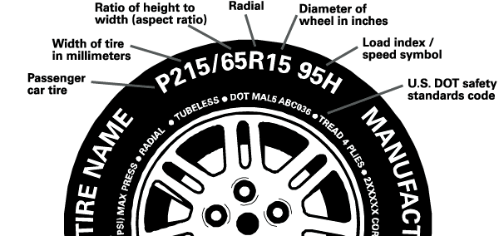

 | Front Right | Back Right | Front Left | Back Left | Example
Manufacturer: |  |  |  |  | Goodyear
Model: |  |  |  |  | Assurance
Size: |  |  |  |  | P215/65R15
Speed rating: |  |  |  |  | 95H
DOT number: |  |  |  |  | MAL5 ABC036
Max. Load: |  |  |  |  | 1510 lbs
Recom’d PSI: |  |  |  |  | 35 psi
Actual PSI: |  |  |  |  | 27 psi
Tread depth: |  |  |  |  | 1/32”
Notes / damage:

***all tires should be photographed / close ups should be taken of damage***
Vehicle # ____
Pre – impact dimensions (in inches)
Wheelbase |  | Overall length
Tracking width (front) |  | Overall width
Tracking width (rear) |  | Overall height
Front bumper height |  | Front overhang
Rear bumper height |  | Rear overhang
Longitudinal distance from front bumper to base of windshield
Hood height |  | Curb Weight
Front weight distribution |  | Back weight distribution

Post – impact dimensions (in inches)
Wheelbase |  | Overall length
Tracking width (front) |  | Overall width
Tracking width (rear) |  | Overall height
Front bumper height |  | Front overhang
Rear bumper height |  | Rear overhang
Longitudinal distance from front bumper to base of windshield
Hood height |  | Total Weight
Front Left Weight |  | Front Right Weight
Back Left Weight |  | Back Right Weight

Notes / Additional measurements:
Vehicle # ____
Light Bulb Examination
Indicate which bulbs were examined and/or seized. Make sure that bulbs are properly labeled on Evidence cards. Each area of the vehicle has several possible bulb locations, so be as specific as possible. Use arrows and labels on the diagram below. Use the following page to sketch bulb filaments or make additional notes.

Vehicle # ____
Light Bulb Examination

Describe the Exterior of Vehicle # ____

Additional Notes (Vehicle # ____)

Vehicle # ____
Color: __________ Year: _______ Make: ______________ Model: ___________
Tag: _________________ State: ________ Year: ___________
Sticker matches tag? Yes / No
VIN: ___ ___ ___ ___ ___ ___ ___ ___ ___ ___ ___ ___ ___ ___ ___ ___ ___
VIN matches registration? Yes / No
Inspection expires: ______ / _______ Inspection serial #: _______________________
Mileage: _____________
Speedometer reading: ______________ Tachometer reading: __________________
Transmission (gear): _______________ Headlight switch position: _______________
Location of keys: _______________________________________________________
Driver’s side airbag? Yes / No Deployed? Yes / No
Passenger’s side airbag? Yes / No Deployed? Yes / No Switch? Yes / No
Side airbags? Yes / No if yes, describe: ___________________________________
ABS brakes? Yes / No EDR? Yes / No if yes, downloaded? Yes / No
Vehicle Towed by: ______________________________________________________
Owner of Vehicle: ______________________________________________________
Address: ______________________________________________________________
DOB: _______________________ OL#/State: _______________________________
Phone Numbers: Home (____)_____________ Work (____)_____________
Cell (____)______________ Other (____)_____________
Describe the interior of the vehicle, including an inventory of relevant items:
Vehicle # ____

Sketch the
damaged areas

The top
of the page
is the
front of the
vehicle

Makes notes
to describe
damage

Vehicle # ____

 | Front Right | Back Right | Front Left | Back Left | Example
Manufacturer: |  |  |  |  | Goodyear
Model: |  |  |  |  | Assurance
Size: |  |  |  |  | P215/65R15
Speed rating: |  |  |  |  | 95H
DOT number: |  |  |  |  | MAL5 ABC036
Max. Load: |  |  |  |  | 1510 lbs
Recom’d PSI: |  |  |  |  | 35 psi
Actual PSI: |  |  |  |  | 27 psi
Tread depth: |  |  |  |  | 1/32”
Notes / damage:

***all tires should be photographed / close ups should be taken of damage***
Vehicle # ____
Pre – impact dimensions (in inches)
Wheelbase |  | Overall length
Tracking width (front) |  | Overall width
Tracking width (rear) |  | Overall height
Front bumper height |  | Front overhang
Rear bumper height |  | Rear overhang
Longitudinal distance from front bumper to base of windshield
Hood height |  | Curb Weight
Front weight distribution |  | Back weight distribution

Post – impact dimensions (in inches)
Wheelbase |  | Overall length
Tracking width (front) |  | Overall width
Tracking width (rear) |  | Overall height
Front bumper height |  | Front overhang
Rear bumper height |  | Rear overhang
Longitudinal distance from front bumper to base of windshield
Hood height |  | Total Weight
Front Left Weight |  | Front Right Weight
Back Left Weight |  | Back Right Weight

Notes / Additional measurements:
Vehicle # ____
Light Bulb Examination
Indicate which bulbs were examined and/or seized. Make sure that bulbs are properly labeled on Evidence cards. Each area of the vehicle has several possible bulb locations, so be as specific as possible. Use arrows and labels on the diagram below. Use the following page to sketch bulb filaments or make additional notes.

Vehicle # ____
Light Bulb Examination

Describe the Exterior of Vehicle # ____

Additional Notes (Vehicle # ____)

Driver/Ped # ____
Name: _______________________________________________________________
Address: ______________________________________________________________
DOB: _______________________ OL#/State: _______________________________
Phone Numbers: Home (____)_____________ Work (____)_____________
Cell (____)______________ Other (____)_____________
Race: ______ Gender: ______ Height: ______ Weight: ______
Seatbelt used? Yes / No Airbag deployed? Yes / No
Impairment checked for by ____________________ at ______ hrs
Tests given? PBT HGN WAT OLS FtN Rmbrg Blood Intox5000 None
If none, explain:____________________________________________________
Officer’s opinion? Subject is impaired / Subject is not impaired
***If subject is impaired, follow DWI protocol***
***If subject refuses test obtain a search warrant for a blood sample***
Injured? Yes / No Taken to hospital? Yes / No if yes, which? _______________
If injured, fill out injury descriptions on next page
Killed? Yes / No next of kin notified? Yes / No if yes, by who? _______________
at what time? _______________
Next of Kin Information
Name/Relationship: _____________________________________________________
Address: ______________________________________________________________
DOB: _______________________ OL#/State: _______________________________
Phone Numbers: Home (____)_____________ Work (____)_____________
Cell (____)______________ Other (____)_____________

Written statement obtained? Yes / No by which officer? ______________________
Face-to-face interview? Yes / No by which officer? __________________________

Driver/Ped # ____
Injury Descriptions
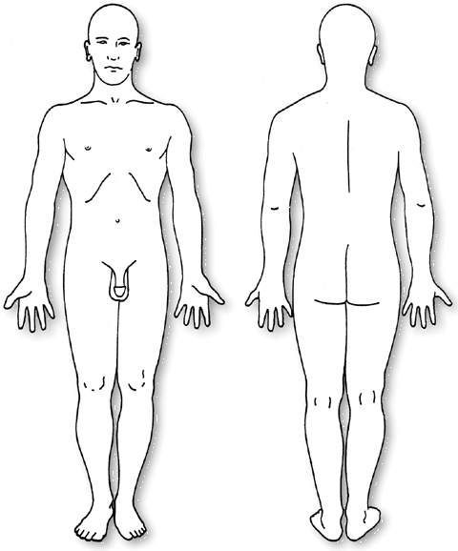
Describe injuries and injury locations. Photographs should be taken of all injuries.
Description / Statement of Driver/Ped # ____
Include clothing description, odors, statements, demeanor and actions:

Driver/Ped # ____
Name: _______________________________________________________________
Address: ______________________________________________________________
DOB: _______________________ OL#/State: _______________________________
Phone Numbers: Home (____)_____________ Work (____)_____________
Cell (____)______________ Other (____)_____________
Race: ______ Gender: ______ Height: ______ Weight: ______
Seatbelt used? Yes / No Airbag deployed? Yes / No
Impairment checked for by ____________________ at ______ hrs
Tests given? PBT HGN WAT OLS FtN Rmbrg Blood Intox5000 None
If none, explain:____________________________________________________
Officer’s opinion? Subject is impaired / Subject is not impaired
***If subject is impaired, follow DWI protocol***
***If subject refuses test obtain a search warrant for a blood sample***
Injured? Yes / No Taken to hospital? Yes / No if yes, which? _______________
If injured, fill out injury descriptions on next page
Killed? Yes / No next of kin notified? Yes / No if yes, by who? _______________
at what time? _______________
Next of Kin Information
Name/Relationship: _____________________________________________________
Address: ______________________________________________________________
DOB: _______________________ OL#/State: _______________________________
Phone Numbers: Home (____)_____________ Work (____)_____________
Cell (____)______________ Other (____)_____________

Written statement obtained? Yes / No by which officer? ______________________
Face-to-face interview? Yes / No by which officer? __________________________

Driver/Ped # ____
Injury Descriptions
Describe injuries and injury locations. Photographs should be taken of all injuries.
Description / Statement of Driver/Ped # ____
Include clothing description, odors, statements, demeanor and actions:

Occupant of Vehicle # ____
Name: _______________________________________________________________
Address: ______________________________________________________________
DOB: _______________________ OL#/State: _______________________________
Phone Numbers: Home (____)_____________ Work (____)_____________
Cell (____)______________ Other (____)_____________
Race: ______ Gender: ______ Height: ______ Weight: ______
Seating position and DMV code: ___________________________________________
Seatbelt used? Yes / No Airbag deployed? Yes / No
Impairment checked for by ____________________ at ______ hrs
Tests given? PBT HGN WAT OLS FtN Rmbrg Blood Intox5000 None
If none, explain:____________________________________________________
Officer’s opinion? Subject is impaired / Subject is not impaired
Injured? Yes / No Taken to hospital? Yes / No if yes, which? _______________
If injured, fill out injury descriptions on next page
Killed? Yes / No next of kin notified? Yes / No if yes, by who? _______________
at what time? _______________
Next of Kin Information
Name/Relationship: _____________________________________________________
Address: ______________________________________________________________
DOB: _______________________ OL#/State: _______________________________
Phone Numbers: Home (____)_____________ Work (____)_____________
Cell (____)______________ Other (____)_____________

Written statement obtained? Yes / No by which officer? ______________________
Face-to-face interview? Yes / No by which officer? __________________________

Occupant of Vehicle # ____
Injury Descriptions
Describe injuries and injury locations. Photographs should be taken of all injuries.
Description / Statement of Occupant of Vehicle # ____
Include clothing description, odors, statements, demeanor and actions:

Occupant of Vehicle # ____
Name: _______________________________________________________________
Address: ______________________________________________________________
DOB: _______________________ OL#/State: _______________________________
Phone Numbers: Home (____)_____________ Work (____)_____________
Cell (____)______________ Other (____)_____________
Race: ______ Gender: ______ Height: ______ Weight: ______
Seating position and DMV code: ___________________________________________
Seatbelt used? Yes / No Airbag deployed? Yes / No
Impairment checked for by ____________________ at ______ hrs
Tests given? PBT HGN WAT OLS FtN Rmbrg Blood Intox5000 None
If none, explain:____________________________________________________
Officer’s opinion? Subject is impaired / Subject is not impaired
Injured? Yes / No Taken to hospital? Yes / No if yes, which? _______________
If injured, fill out injury descriptions on next page
Killed? Yes / No next of kin notified? Yes / No if yes, by who? _______________
at what time? _______________
Next of Kin Information
Name/Relationship: _____________________________________________________
Address: ______________________________________________________________
DOB: _______________________ OL#/State: _______________________________
Phone Numbers: Home (____)_____________ Work (____)_____________
Cell (____)______________ Other (____)_____________

Written statement obtained? Yes / No by which officer? ______________________
Face-to-face interview? Yes / No by which officer? __________________________

Occupant of Vehicle # ____
Injury Descriptions
Describe injuries and injury locations. Photographs should be taken of all injuries.
Description / Statement of Occupant of Vehicle # ____
Include clothing description, odors, statements, demeanor and actions:

Occupant of Vehicle # ____
Name: _______________________________________________________________
Address: ______________________________________________________________
DOB: _______________________ OL#/State: _______________________________
Phone Numbers: Home (____)_____________ Work (____)_____________
Cell (____)______________ Other (____)_____________
Race: ______ Gender: ______ Height: ______ Weight: ______
Seating position and DMV code: ___________________________________________
Seatbelt used? Yes / No Airbag deployed? Yes / No
Impairment checked for by ____________________ at ______ hrs
Tests given? PBT HGN WAT OLS FtN Rmbrg Blood Intox5000 None
If none, explain:____________________________________________________
Officer’s opinion? Subject is impaired / Subject is not impaired
Injured? Yes / No Taken to hospital? Yes / No if yes, which? _______________
If injured, fill out injury descriptions on next page
Killed? Yes / No next of kin notified? Yes / No if yes, by who? _______________
at what time? _______________
Next of Kin Information
Name/Relationship: _____________________________________________________
Address: ______________________________________________________________
DOB: _______________________ OL#/State: _______________________________
Phone Numbers: Home (____)_____________ Work (____)_____________
Cell (____)______________ Other (____)_____________

Written statement obtained? Yes / No by which officer? ______________________
Face-to-face interview? Yes / No by which officer? __________________________

Occupant of Vehicle # ____
Injury Descriptions
Describe injuries and injury locations. Photographs should be taken of all injuries.
Description / Statement of Occupant of Vehicle # ____
Include clothing description, odors, statements, demeanor and actions:

Occupant of Vehicle # ____
Name: _______________________________________________________________
Address: ______________________________________________________________
DOB: _______________________ OL#/State: _______________________________
Phone Numbers: Home (____)_____________ Work (____)_____________
Cell (____)______________ Other (____)_____________
Race: ______ Gender: ______ Height: ______ Weight: ______
Seating position and DMV code: ___________________________________________
Seatbelt used? Yes / No Airbag deployed? Yes / No
Impairment checked for by ____________________ at ______ hrs
Tests given? PBT HGN WAT OLS FtN Rmbrg Blood Intox5000 None
If none, explain:____________________________________________________
Officer’s opinion? Subject is impaired / Subject is not impaired
Injured? Yes / No Taken to hospital? Yes / No if yes, which? _______________
If injured, fill out injury descriptions on next page
Killed? Yes / No next of kin notified? Yes / No if yes, by who? _______________
at what time? _______________
Next of Kin Information
Name/Relationship: _____________________________________________________
Address: ______________________________________________________________
DOB: _______________________ OL#/State: _______________________________
Phone Numbers: Home (____)_____________ Work (____)_____________
Cell (____)______________ Other (____)_____________

Written statement obtained? Yes / No by which officer? ______________________
Face-to-face interview? Yes / No by which officer? __________________________

Occupant of Vehicle # ____
Injury Descriptions
Describe injuries and injury locations. Photographs should be taken of all injuries.
Description / Statement of Occupant of Vehicle # ____
Include clothing description, odors, statements, demeanor and actions:

Witness
Name: _______________________________________________________________
Address: ______________________________________________________________
DOB: _______________________ OL#/State: _______________________________
Phone Numbers: Home (____)_____________ Work (____)_____________
Cell (____)______________ Other (____)_____________
Race: ______ Gender: ______
Witness in a vehicle? Yes / No if yes, describe vehicle, including tag number:
Color: __________ Year: _______ Make: ______________ Model: ___________
Tag: _________________ State: ________ Year: ___________
Written statement obtained? Yes / No by which officer? ______________________
Face-to-face interview? Yes / No by which officer? __________________________
Description / Interview of Witness

Include clothing description, odors, statements, demeanor and actions:

Witness
Name: _______________________________________________________________
Address: ______________________________________________________________
DOB: _______________________ OL#/State: _______________________________
Phone Numbers: Home (____)_____________ Work (____)_____________
Cell (____)______________ Other (____)_____________
Race: ______ Gender: ______
Witness in a vehicle? Yes / No if yes, describe vehicle, including tag number:
Color: __________ Year: _______ Make: ______________ Model: ___________
Tag: _________________ State: ________ Year: ___________
Written statement obtained? Yes / No by which officer? ______________________
Face-to-face interview? Yes / No by which officer? __________________________
Description / Interview of Witness

Include clothing description, odors, statements, demeanor and actions:

Witness
Name: _______________________________________________________________
Address: ______________________________________________________________
DOB: _______________________ OL#/State: _______________________________
Phone Numbers: Home (____)_____________ Work (____)_____________
Cell (____)______________ Other (____)_____________
Race: ______ Gender: ______
Witness in a vehicle? Yes / No if yes, describe vehicle, including tag number:
Color: __________ Year: _______ Make: ______________ Model: ___________
Tag: _________________ State: ________ Year: ___________
Written statement obtained? Yes / No by which officer? ______________________
Face-to-face interview? Yes / No by which officer? __________________________
Description / Interview of Witness

Include clothing description, odors, statements, demeanor and actions:

Witness
Name: _______________________________________________________________
Address: ______________________________________________________________
DOB: _______________________ OL#/State: _______________________________
Phone Numbers: Home (____)_____________ Work (____)_____________
Cell (____)______________ Other (____)_____________
Race: ______ Gender: ______
Witness in a vehicle? Yes / No if yes, describe vehicle, including tag number:
Color: __________ Year: _______ Make: ______________ Model: ___________
Tag: _________________ State: ________ Year: ___________
Written statement obtained? Yes / No by which officer? ______________________
Face-to-face interview? Yes / No by which officer? __________________________
Description / Interview of Witness
Include clothing description, odors, statements, demeanor and actions:

ADDITIONAL INFORMATION TO OBTAIN FOR UNUSUAL CRASHES

For crashes involving a train:
Identify the following people: engineer, brakeman, flagman, conductor
Obtain the engine information and the total number of cars
Check the following: headlight, horn, bell, sand box
At the crossing, check the following: barricades, signal lights, bell, signs
***The engineer does not have to produce a driver’s license***

For crashes involving a motorcycle, moped, bicycle:
Check for safety equipment: helmet, eye protection, pads
Be sure and check lights and reflectors to insure functionality

For pedestrian crashes
Clothing descriptions and lighting descriptions are critical

