**ASSISTANT STATE’S ATTORNEY**

The Office of the State’s Attorney for Prince George’s County is seeking an experienced prosecutor to fill an Assistant State’s Attorney **position with the Special Victims and Family Violence Unit** to work with local, state, and federal law enforcement authorities to investigate and prosecute crimes related to domestic violence, child physical and sexual abuse; sexual assault; child pornography and human sex and labor trafficking.  It is an exempt position, meaning the position is a political appointment and serves at the pleasure of the State’s Attorney.

**LATERAL POSITION**

This is a lateral position that requires:

* License to practice in the State of Maryland;
* Knowledge of the principles and practices of law, including court procedures and legal research methods and sources;
* Ability to handle a high volume court docket involving a variety of complex cases effectively;
* Ability to interview victims and witnesses to gather information, research relevant case law and codes for applicability to varying legal issues, determine appropriate sentence recommendations and guidelines, and to develop strategies and theories for effective case prosecution;
* Ability to draft and prepare a variety of legal documents, including but not limited to briefs, motions and legal memoranda;
* Coordination with other County and State agencies that provide assistance, protection and services to victims and witnesses;
* Participation in community engagement initiatives; and,
* Performance of related work as required.

**TYPICAL DUTIES**

Typical duties for an Assistant State’s Attorney –include:

* Reviewing criminal charging documents and providing direction to law enforcement during investigations;
* Interviewing witnesses
* Guiding criminal investigations, including complex, proactive investigations
* Complying with discovery obligations;
* Drafting indictments, pleadings, and other court filings
* Preparing cases to be presented in court;
* Drafting and arguing pre-trial and post-trial motions; and
* Clearly and logically presenting facts and evidence to a judge or jury during trial
* Disseminating expertise through interagency enforcement initiatives, trainings, guidance, and strategic engagements with enforcement partners

**MINIMUM QUALIFICATION FOR CANDIDATES**

Candidates must have graduated from an accredited law school, and be licensed to practice law in the state of Maryland. Additionally, candidates must have a minimum of three to four (3-4) years of litigation experience and the ability to work independently.

**CONDITIONS OF EMPLOYMENT**

1. Must pass a background investigation, which includes fingerprinting
2. Must pass a drug screen

**ELIGIBILITY TO WORK**:  Under the Immigration Reform and Control Act of 1986, an employer is required to hire only U.S. citizens and lawfully authorized alien workers.  Selected candidate for employment will be required to show and verify authorization to work in the United States.

**CLOSING DATE**: Open Until Filled

**HOW TO APPLY**: Submit cover letter, resume and writing sample to:  Human Resources Manager, Office of the State’s Attorney for Prince George’s County, [SAOHumanresources@co.pg.md.us](mailto:SAOHumanresources@co.pg.md.us). Please include information as to trial experience (i.e. number of trials had, whether jury or a bench trials, and your role during trial.

**An Equal Opportunity Employer**

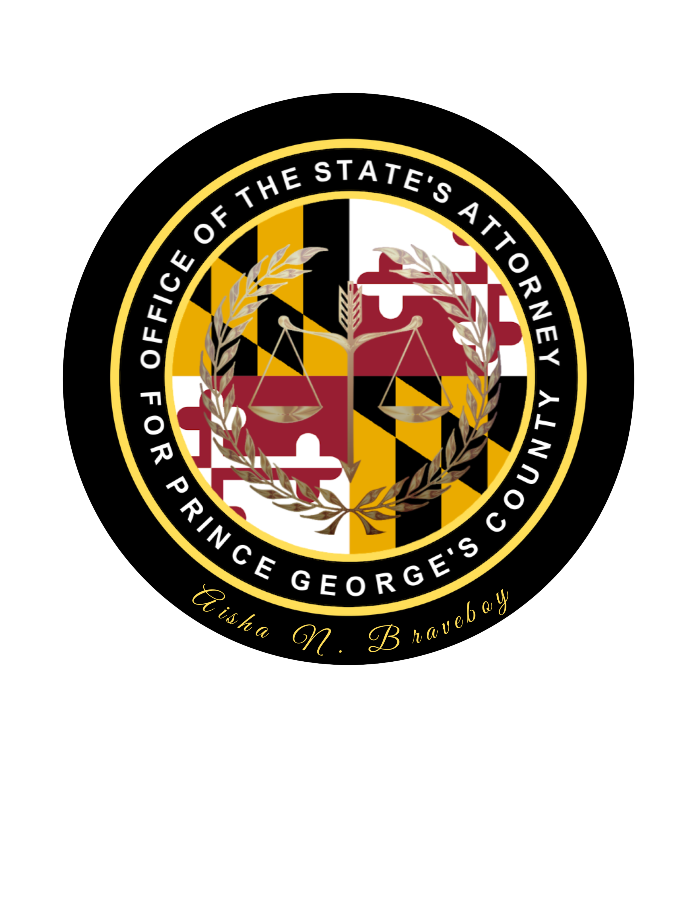

**OFFICE OF THE STATE’S ATTORNEY FOR PRINCE GEORGE’S COUNTY**

Job Announcement