RECRUITMENT FAIR SAMPLE NEWSLETTER, EMAIL
& FLYER MESSAGING

- Sample Messaging for Newsletters

These sample messages can be provided to the law school’s career center, alumni network, and student societies for inclusion in their newsletters. Alter as necessary to reflect your key selling points and profiles of current law students. Include pictures from your office or royalty-free imagery for visual attention.

Sample e-Newsletter Design Layout:

Short Blurb:
Eager for courtroom experience? Attend our Prosecutor Recruitment Fair on [Date] and explore a career path that gets you in the courtroom soon after graduation. Register now [insert registration link] to secure your spot!

Medium Blurb:
Do you envision yourself in the courtroom, actively shaping the course of justice? Discover a career that places you in the heart of the action. Join us at our Prosecutor Recruitment Fair on [Date] to learn about careers in prosecution that offer valuable courtroom experience straight after law school. Reserve your place today [insert registration link]!

Long Blurb:
Are you a law student looking to gain courtroom experience immediately after graduation? Consider a career as a prosecutor. Join us at our Prosecutor Recruitment Fair on [Date] to learn more.
This event provides an opportunity to network with representatives from leading prosecutor's offices and discover the exciting possibilities a career in prosecution offers. A career as a prosecutor not only allows you to uphold justice but also ensures a hands-on courtroom experience right from the start.

Don't miss this chance to explore a career that takes you straight to the heart of the justice system. Register now [insert registration link] and kickstart your journey to the courtroom.

Sample Graphic for Newsletters, Emails & Social Media:

- Sample Email Messaging to Law Students
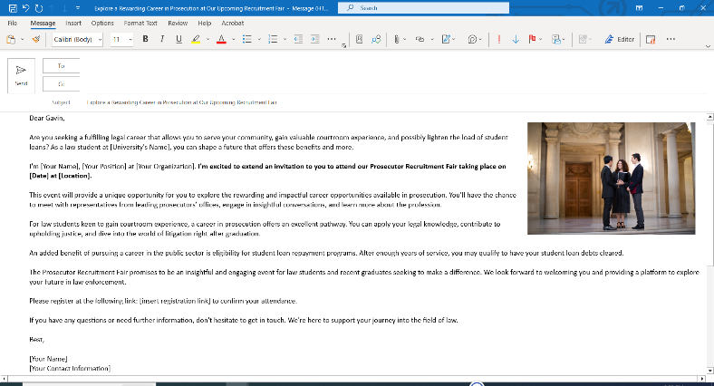

This email template can be used to send out emails directly to a list-serv of students. Ask the law school’s career center, alumni network, and student societies to send an email directly to their students and members. Alter as necessary to reflect your key selling points and profiles of current law students.

Subject: Explore a Rewarding Career in Prosecution at Our Upcoming Recruitment Fair

Dear [Recipient's Name],

Are you seeking a fulfilling legal career that allows you to serve your community, gain valuable courtroom experience, and possibly lighten the load of student loans? As a law student at [University's Name], you can shape a future that offers these benefits and more.

I'm [Your Name], [Your Position] at [Your Organization]. I'm excited to extend an invitation to you to attend our Prosecutor Recruitment Fair taking place on [Date] at [Location].

This event will provide a unique opportunity for you to explore the rewarding and impactful career opportunities available in prosecution. You'll have the chance to meet with representatives from leading prosecutors’ offices, engage in insightful conversations, and learn more about the profession.

For law students keen to gain courtroom experience, a career in prosecution offers an excellent pathway. You can apply your legal knowledge, contribute to upholding justice, and dive into the world of litigation right after graduation.

An added benefit of pursuing a career in the public sector is eligibility for student loan repayment programs. After enough years of service, you may qualify to have your student loan debts cleared.

The Prosecutor Recruitment Fair promises to be an insightful and engaging event for law students and recent graduates seeking to make a difference. We look forward to welcoming you and providing a platform to explore your future in law enforcement.

Please register at the following link: [insert registration link] to confirm your attendance.

If you have any questions or need further information, don't hesitate to get in touch. We're here to support your journey into the field of law.

Best,

[Your Name]
[Your Contact Information]

3. FLYER MESSAGING

Flyer Visuals: Remember to include engaging visuals. You could have images of young prosecutors in action, graphics showing the steps to becoming a prosecutor, or even a simple yet professional design with your organization's branding.
Flyer Design Tips: Ensure the flyer is easy to read with clear headings and bullet points. Use your organization's color scheme for consistency, and make sure the registration link is noticeable. Finally, include your office’s logo for branding purposes.
Flyer Templates: Microsoft PowerPoint and Word both offer professionally designed templates for flyers and posters, allowing for quick and easy customization for flyers and posters.

Sample Messaging: [Update to reflect market trends and key selling points of your office]

Shape Your Future in Law: Prosecutor Recruitment Fair
Discover a rewarding legal career that lets you serve your community, gain courtroom experience, and access student loan repayment opportunities.

Join us on [Date] at [Location] to explore the world of prosecution. Meet with representatives from top prosecutor's offices, network with like-minded law students, and learn how you can make a real impact in your community.

Why attend?
- Learn about the fulfilling work prosecutors do every day.
- Understand how you can gain valuable courtroom experience straight after graduation.
- Discover the student loan repayment programs available in the public sector.

Don't miss this unique opportunity to kickstart your legal career and make a difference in the world.

Register today! [insert registration link]

[Your Organization's Name]
[Your Contact Information]
Follow us on [social media handles]

