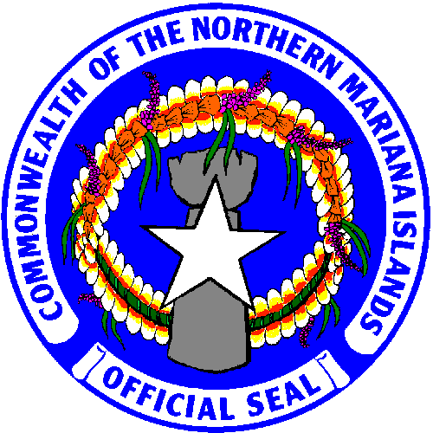
Commonwealth of the Northern Mariana Islands
Office of the Attorney General
2nd Floor Hon. Juan A. Sablan Memorial Bldg.
Caller Box 10007, Capitol Hill
Saipan, MP 96950

EDWARD MANIBUSAN LILLIAN A. TENORIO
Attorney General Deputy Attorney General

EMPLOYMENT OPPORTUNITY ANNOUNCEMENT

JOB TITLE: Chief Prosecutor

The Office of the Attorney General of the Commonwealth of the Northern Mariana Islands is currently seeking applicants for the position of Chief Prosecutor. The Commonwealth of the Northern Mariana Islands (CNMI) is a government in political union with the United States of America. It consists of several islands in the Pacific Ocean located north of Guam, including the islands of Saipan, Tinian, and Rota. The Commonwealth judiciary consists of five Superior Court judges and a Supreme Court consisting of three justices. The Commonwealth is part of the United States Court of Appeals for the Ninth Circuit.

The successful applicant must be a member of a state or territorial bar association in good standing, making him or her eligible for a four-year temporary admittance to the Commonwealth Bar as a government attorney. Applicant must possess strong academic credentials from an ABA-accredited law school, demonstrate excellent writing and advocacy skills, and work effectively in a team environment. The term of the initial contract for the successful applicant will be two years.

NATURE OF WORK: This position is located at the CNMI Office of the Attorney General and is under the general supervision of the Attorney General and/or his designee.

DUTIES AND RESPONSIBILITIES:

• Responsible for supervising and coordinating all activities regarding criminal matters handled by the Office of the Attorney General.

• Supervises the efforts of all attorneys within the Criminal Division, the Special Prosecution Unit, and any other Assistant Attorneys General who handle criminal prosecution.

• Supervises the prosecution of violation of CNMI criminal, juvenile and traffic laws.

• Provides legal advice regarding criminal law and procedures to all law enforcement agencies within the CNMI in regards to potential or pending investigations and pending prosecutions.

- Recruit, interview, train and supervise Division staff. Review personnel issues. Review and consult with the Attorney General or designee on attorney leave requests, work schedules, time sheets, travel authorizations and contract requests.

- Provide training and mentoring of Division attorneys.
- Oversee the formulation and implementation of short-term and long-term goals designed to enhance efficiency and effectiveness. Oversee the development and implementation of policies, procedures and protocols within the Division through coordination with the Attorney General or designee.
- Act as liaison with courts and their staff on questions of case management and compliance with local rules.
- Review pending legislation and proposed rules affecting prosecution.
- Maintain an appropriate case load in addition to administrative duties described herein.
- Perform other legal and administrative duties as assigned at the direction of the Attorney General or designee.

CONTACT:
Tina Deleon Guerrero, Office Manager
Email: tina_deleonguerrero@cnmioag.org

***Please send cover letter, resume, two writing samples, and date of availability should an offer be extended.
Applicants will be considered on a rolling basis.

