COURTING LAW STUDENTS:
A RECRUITMENT FAIR GUIDE FOR PROSECUTORS’ OFFICES
Developed by the National District Attorneys Association

- INTRODUCTION

As an organization dedicated to supporting and enhancing the effectiveness of prosecutors in their efforts to create safer communities, we understand that attracting the right talent is a cornerstone of achieving our mission. This toolkit aims to support prosecutors’ offices nationwide in their recruitment endeavors.

The recruitment process can be multifaceted and demanding. We've designed this toolkit to streamline the process, offer valuable insights, and provide practical tools that prosecutors’ offices of all sizes can implement to attract, engage, and recruit top-notch law school students.

The toolkit is organized into four key sections, each focusing on a different phase of the recruitment process:

Pre-Recruitment Fair Preparation:
Provides a roadmap to effectively prepare for a recruitment fair, including research, strategic planning, event logistics, marketing and promotion, material preparation, and team training.

During the Recruitment Fair:
Strategies and practices that can enhance your presence at the fair, from effective booth management to engaging potential applicants, conducting on-the-spot interviews, and networking.

Post-Recruitment Fair Follow-Up:
Maximize the benefits of the recruitment fair by using our strategies for follow-up communication, conducting formal interviews, analyzing data for future improvements, maintaining continued engagement with candidates, and fostering partnerships and relationships for ongoing recruitment.

Resources:
Includes a compilation of additional resources, such as checklists, templates, and discussion guides, designed to assist in the execution of the strategies discussed in this toolkit.

- Pre-Recruitment Fair Preparation

1. Research and Strategic Planning

- Identify Key Law Schools and Target Demographics:

It’s important that the approach to potential partner law schools is inclusive to ensure you’re reaching a diverse range of potential candidates. Focus especially on schools that have demonstrated commitment to criminal justice, social justice, and/or public services. These schools could be determined by various factors, including:

Commitment to Public Service: Look for schools with strong programs or initiatives related to criminal justice, public service, or social justice. These schools might not be traditionally ranked as 'top' law schools, but their commitment to these areas indicates a student body likely to be interested in a career as a prosecutor.

Innovative and Improving Programs: Recognize schools that have dedicated time and resources to improve their programming and offer more to their students. These schools might have innovative curricula or hands-on experiences that produce highly qualified graduates ready to contribute from day one.

Regional Proximity: Local or regional schools could be a valuable resource. Students are often familiar with the local community and legal system and may be more likely to remain in the area post-graduation.

Historical Relationships: Maintain relationships with schools that have historically provided motivated and successful candidates.

Diversity and Inclusion Efforts, including HBCUs: Proactively reach out to schools that have a strong commitment to diversity and inclusion. This could include historically black colleges and universities (HBCUs), schools with significant populations of first-generation students, or schools known for serving other underrepresented communities. This approach ensures a diverse candidate pool, which can strengthen the prosecutor's office and better reflect the community it serves.

By expanding the selection criteria in this way, we ensure a more inclusive approach to recruitment, giving opportunities to a broader range of potential candidates and strengthening the diversity and quality of your applicant pool.

Engage with Diverse Student Demographics
To ensure the widest pool of talent, it’s essential to engage with a variety of student demographics. This approach goes beyond reaching out to students who are immediately interested in prosecution and instead focuses on cultivating interest and providing opportunities for students from different backgrounds. Consider the following strategies:

First-Generation Law Students: Often overlooked, first-generation law students bring a unique perspective to the legal profession. They could greatly benefit from and contribute to a career in prosecution. Outreach programs can help familiarize them with the opportunities available.

Students with Diverse Academic Interests: Do not limit outreach to those who are pursuing a concentration in criminal law. Students with other academic interests can also be valuable assets to a prosecutor's office. For example, students specializing in technology law can contribute to cybercrime units, while those studying family law can support domestic violence cases.

Underrepresented Minority Students: Reach out to clubs and organizations for underrepresented minorities in law schools. This can help create a diverse applicant pool, which in turn contributes to a prosecutor's office that reflects the community it serves.

Students from Various Socioeconomic Backgrounds: A prosecutor's office can benefit from a workforce that understands a variety of life experiences. Engage with scholarship programs, access initiatives, and clubs that assist students from various socioeconomic backgrounds.

Non-Traditional Students: Non-traditional students, such as those who are older or have had prior careers, can bring a wealth of experience and a different perspective to the role of a prosecutor.

Targeting a wide range of demographics ensures that the recruitment process is fair and equitable and allows the prosecutor's office to benefit from a rich variety of experiences and perspectives. It’s essential to engage with these different groups through targeted outreach, presentations, and mentorship programs.

- Understand Market Trends and Job Interests among Law Students:

To attract and retain the best talent, staying informed about current job market trends and the interests and expectations of today's law students is crucial. Here are some things to consider:

Social Impact: Today's law students are increasingly interested in roles that positively impact society. Showcasing the meaningful work prosecutors do, and how they contribute to justice and society, can be a powerful attraction.

Diverse Career Interests: While many law students are interested in traditional legal paths, an increasing number are exploring unconventional routes, such as technology law, environmental law, human rights law, and more. Outreach and recruitment efforts should consider and highlight the various facets of prosecutorial work that might align with these diverse interests.

Work-Life Balance: Many students entering the job market highly value work-life balance. They are attracted to organizations that support flexible work schedules, remote working, and provide ample vacation time. Demonstrating a commitment to work-life balance can make prosecutorial work more appealing.

Technology and Innovation: Tech-savvy students are interested in how legal workplaces are leveraging technology. Highlight the ways your office uses technology in its work, from digital evidence management to virtual courtrooms.

Professional Development: Career progression and development opportunities are very important to today's law students. Highlighting the growth and learning opportunities within a prosecutor's office can help attract ambitious students.

Diversity and Inclusion: Law students today are seeking workplaces that are committed to diversity and inclusion. Showcasing diversity within your office and your office's commitment to fostering an inclusive environment can be a strong selling point.

- Decide on Key Selling Points of Your Office:

It's essential to effectively communicate the unique benefits and opportunities that come with the role of a prosecutor. It's not only about what the student can offer the office but also what the office can offer the student. Here are some aspects to consider:

Meaningful Work & Public Service: Emphasize the real impact a prosecutor's work has on the community. Highlight how they help ensure justice and safety and uphold the rule of law. Use real-life examples to illustrate the tangible difference your office makes.

Variety and Complexity of Work: Prosecution offices deal with a wide range of case types, from misdemeanors to high-profile felonies. Highlight this variety to appeal to students who seek intellectually stimulating and challenging work.

Early Responsibility: Entry-level prosecutors often have the chance to manage cases and go to trial far earlier than their peers in other areas of law. This can be a strong selling point for ambitious law students seeking hands-on experience.

Professional Development: Discuss the training programs, mentorship, and learning opportunities your office offers. Emphasize opportunities for advancement within the office and how the experience can provide a strong foundation for any legal career.

Community Involvement: Prosecutors play a key role in community outreach and crime prevention. If your office participates in community programs or initiatives, be sure to highlight this aspect.

Work-life Balance: If your office has policies supporting work-life balance, it can be a significant advantage in attracting law students seeking this quality. If your office offers flexible work hours, telework, or other work-life balance benefits, be sure to promote these points.

Student Loan Forgiveness: High student loan debt is a factor for many law students. The John R. Justice (JRJ) Program provides loan repayment assistance for prosecutors who remain employed as a prosecutor or public defender for at least three years. Additionally, the Public Service Loan Forgiveness (PSLF) program offers students with federal student loans to have their debt forgiven following a term of government or non-profit service.

By effectively showcasing the unique selling points of your office, you can differentiate yourself from other employers and make your office a more attractive proposition for talented law students. It's essential to tailor these selling points to resonate with the specific interests and values of the students you're aiming to attract.

2. Event Logistics

- Choose suitable dates, times, and locations for the fairs:

Consider the following factors when planning your event:
- Review academic calendars and key events.
- Avoid exam periods, holidays, or other significant events that might deter participation.
- Host the fair in easily accessible areas on campus.

Timing within the Academic Year:

Early in the Fall Semester: Career fairs held early in the fall semester can be beneficial as they reach law students when they're just starting their academic year and beginning to consider summer internships, externships, or post-graduation opportunities. By scheduling the fair early, you also avoid the end-of-semester stress and the holiday season.

Early Spring Semester: Another favorable time could be the early spring semester. By this point, 1L students are more acclimated to the law school experience and are seriously beginning to seek out summer opportunities, while 2L and 3L students may be seeking externships or permanent positions.

Timing within the Week:

Mid-Week: Tuesdays, Wednesdays, and Thursdays are typically the best days to hold a recruitment fair. These days avoid conflicts with students' weekend plans and Monday's return-to-work catch-up tasks.

Timing within the Day:

Lunchtime: A career fair held over lunchtime (say, 11 AM to 2 PM) can be convenient for many students who can drop by in between their classes. Providing light refreshments or lunch can also be a draw.

Late Afternoon/Early Evening: Another optimal time could be late afternoon to early evening (say, 3 PM to 6 PM). Classes are often over for the day, but it's not yet late evening when students might be less inclined to attend.

- Coordinate with law schools for availability and access:

Contact the law schools' career services offices well in advance to secure a date, time, and location for the event. Establish a point of contact at each school who can provide necessary logistical details, access to resources, and event promotion within the school.

- Plan the booth setup, including displays and materials:

Design a booth that is visually appealing and inviting. Make sure your branding is clear. The booth should have:

Promotional materials: flyers, brochures, business cards, and possibly branded giveaways like pens, mugs, or other items.

Visual displays: Banners or posters with engaging visuals and key information about your office.

Multimedia: If feasible, include a laptop or screen displaying a short video or slideshow about your office.

Application materials: Copies of job descriptions, qualification summaries, and application processes.

Ensure that there is enough space for attendees to comfortably engage with the recruiters and materials at your booth.

3. Marketing and Promotion

- Develop Promotional Materials

Ensure your promotional materials reflect your office's values and effectively communicate the opportunities you offer. These materials may include:

Brochures/Flyers: Highlight job descriptions, work environment, and benefits, while emphasizing the societal impact your office has. Include testimonials or success stories from past or present prosecutors to provide a personal touch.

Social Media Posts: Develop shareable posts for platforms where law students are active, such as LinkedIn, Instagram, Twitter, or Facebook. Each post should inform students about the recruitment fair and why they should consider your office.

Emails & Newsletters: Personalized emails can be a great way to reach out to prospective candidates. Where possible, send these to individual students, or use mailing lists provided by law schools. Encourage law school career centers to include your event in their newsletters.

Sample promotional messaging templates are available in the resources section of this toolkit.

- Reach out to Law School Career Centers

Forming strong relationships with career centers can help to expand your reach. Share promotional materials with them, ask them to promote your event, and even consider offering presentations to them about your office and its offerings.

- Leverage Alumni Networks

Utilize your office's alumni to serve as ambassadors, promote the recruitment fair, and provide valuable insights about current students' employment expectations. They provide a personal connection between your office and potential candidates and can contribute to the credibility and appeal of your office. Here's how you can leverage your alumni network:

Ambassadors: Alumni can act as ambassadors for your office. As people who have firsthand experience working in your office, they can speak authentically about the work environment, culture, and opportunities, providing a valuable perspective to prospective applicants.

Promoting the Recruitment Fair: Request your alumni to promote your recruitment fair among their networks, both formally and informally. They can share details of the event through their social media and emails. Personal endorsements like these can carry significant weight and can help attract high-quality candidates.

Insight into Current Trends: Your newest attorneys can provide insights into the latest trends among law students, including what they're looking for in a job, what their concerns are, what questions they may have, and more. This information can be instrumental in shaping your recruitment strategy and ensuring it resonates with your target audience.

Hosting or Participating in Events: Alumni can host or participate in pre-recruitment events like information sessions, panel discussions, or workshops. These events provide opportunities for prospective applicants to engage with someone who has successfully navigated the path they're considering and can provide real-world insights into the role.

Mentoring Prospective Candidates: Alumni can act as mentors to interested candidates, answering questions, providing guidance, and sharing their experiences. This kind of one-on-one interaction can be very persuasive in attracting applicants.

Alumni Testimonials: Gather testimonials from your alumni discussing their experiences at your office and how it benefited their careers. These testimonials can be used in promotional materials, social media posts, or even during the recruitment fair.

- Organize Panel Discussions:

Hosting a panel discussion prior to the recruitment fair could be an effective promotional tool. Inviting alumni or current prosecutors to talk about their experiences can make the work more relatable and enticing to potential candidates. A panel discussion guide is available in the resources section of this toolkit.

Panel Selection: Choose panelists who can offer diverse and comprehensive insights into your office. This could include:

- Current Prosecutors: They can provide firsthand experience of the work, the challenges and rewards, and the opportunities for professional growth.

- Office Alumni: Alumni who have advanced in their careers can speak to the value of their experience at your office, the skills they developed, and how it helped them in their career trajectory.

- Support Staff or Supervisors: They can provide perspectives on the work environment, office culture, mentoring, and professional development opportunities.

- Former Interns or Externs: They can share their experiences, insights, and takeaways from their time at your office, which can be relatable to the students.

Topics to Discuss: The discussion should cover topics that give students a well-rounded understanding of your office and the prosecutor’s role. Consider discussing:

- The Role and Impact: Describe the day-to-day tasks of a prosecutor, the courtroom experiences, the case variety, and how the role impacts the community.

- Office Culture: Discuss the work environment, mentorship programs, diversity initiatives, work-life balance, and other aspects that contribute to a positive and productive office culture.

- Career Development: Discuss the training programs, learning opportunities, potential career paths, and growth opportunities within your office.

- Personal Experiences and Anecdotes: Encourage panelists to share personal stories and experiences. This helps to humanize the office and makes the discussion more engaging.

Format: A moderator-led panel discussion where the moderator poses questions to the panelists could work well. Be sure to include a Q&A session, allowing students to ask their questions. This interaction can be crucial in addressing student concerns and dispelling any misconceptions they may have.

Promotion: Promote the panel discussion in advance through emails, social media, flyers, and the career centers of the law schools you're targeting. Make sure students are aware of the opportunity to learn directly from professionals in the field.

Follow-up: After the panel discussion, consider sending out a follow-up email to attendees, thanking them for their time, providing any referenced resources, and reminding them about the upcoming recruitment fair. This helps maintain engagement with potential applicants and reinforces your office's commitment to open dialogue and transparency.

Organizing a panel discussion as part of your recruitment strategy can provide a more nuanced, engaging, and personal introduction to your office, helping you stand out to potential applicants.

- Partnerships with Law Societies and Student Groups

Law societies and student groups are often influential within their respective law schools. They can provide a channel to engage with a significant portion of your target audience. By forming partnerships with these groups, you can amplify your recruitment efforts and align with the interests and values of potential candidates.

Law Review/Journals: Most law schools have student-run law review journals. As they involve students deeply interested in the law and are often well-respected, they make excellent partners for promotional events.

Moot Court/Mock Trial Teams: Students who participate in moot court or mock trial teams are often interested in litigation and have demonstrated their commitment through extracurricular activities. Partnership with these groups can help you reach potential candidates with a demonstrated interest in the type of work a prosecutor's office does.

Student Bar Association (SBA): The SBA is a student-run organization present in most law schools, representing the interests of law students. Collaborating with the SBA can provide your office with broad exposure to the student body.

Public Interest/Criminal Law Societies: Many law schools have student groups focused on public interest law or criminal law. These students may be particularly interested in a prosecutor's role and can serve as a direct line to a highly relevant audience.

Affinity Groups: Groups like the Black Law Students Association (BLSA), Latinx Law Students Association (LaLSA), Asian Pacific American Law Students Association (APALSA), OUTLaw (LGBTQ+ law student organization), and Women's Law Association can be beneficial in reaching diverse demographic groups within the law school community.

How to Partner with These Groups:

Event Sponsorship/Co-hosting: Sponsor or co-host events such as panel discussions, information sessions, or workshops with these groups. The event can provide students with valuable insights while also promoting your office and the upcoming recruitment fair.

Guest Speakers: Offer to have members from your office serve as guest speakers at group meetings, providing insights into the life and work of a prosecutor.

Promotion: Ask these groups to promote your recruitment fair among their members and in their newsletters or social media channels. In return, offer to promote their events or initiatives.

Joint Workshops or Training Sessions: Consider conducting workshops or training sessions in collaboration with these groups. These could be on topics like courtroom etiquette, legal research, or trial preparation.

Mentorship Programs: Develop a mentorship program where students from these groups can be mentored by attorneys from your office. This provides valuable professional development for the students and promotes your office as a supportive and engaging workplace.

Remember, the key to successful partnerships with law societies and student groups is to ensure that the relationship is mutually beneficial. Aim to contribute to their objectives and support their members while promoting your office and its opportunities.

- Use Digital Advertising

Consider using paid advertising on social media platforms or law industry-specific online platforms to reach a wider audience. Be sure to target these ads to law students in the geographical areas of interest.

All these efforts are aimed at maximizing the visibility of your event and attracting the most suitable and interested candidates. Remember, your promotional efforts are not just to inform, but also to build an appealing image of your prosecutor's office that resonates with potential applicants.

4. MATERIAL PREPARATION

Creating engaging and informative materials is a crucial step in attracting potential applicants. These materials should be designed to provide clear and concise information about your office, the roles available, and the application process, while also painting an attractive picture of your office culture and the meaningful work that you do. Below are steps you can follow to prepare these materials effectively.

- Include Job Descriptions and Qualification Summaries:

Clearly outline the roles, responsibilities, and qualifications of each job opportunity. Each job description should include the title, a summary of the position, and day-to-day tasks and responsibilities. Include the benefits of working in the position, such as the opportunity to gain courtroom experience, contribute to public service, and work in a dynamic and exciting environment. The qualification summaries should highlight the key qualifications required for the role in a condensed, easy-to-read format. These can act as a quick reference for potential applicants at the recruitment fair.

Application Guide: Consider creating a guide detailing the application process and timelines to make it easier for interested candidates. This guide should outline the steps applicants need to take to apply, such as online application, submission of certain documents (like a resume, cover letter, references, or transcripts), any tests or interviews, and more. Also include a sample of the timeline for the application process, including any important deadlines.

- Showcase Office Culture and Impact:

Prepare materials that showcase the culture of your office and the impact of your work. This can help potential applicants envision themselves in your office and understand the meaningful contributions they can make. These materials can include:

Testimonials from current or former employees discussing their experiences in your office and how it's helped their career.
Success Stories from your office, such as significant cases you've prosecuted or initiatives you've undertaken.

Professional Development including any training, mentorship, or professional development opportunities your office offers.

Unique or Special Benefits including work-life balance policies your office may provide.

- Interactive Content:

Prepare videos or interactive presentations that provide a vivid snapshot of your office's work. These could include day-in-the-life videos, case studies, or virtual office tours. If you don’t have in-house video capabilities, consider using NDAA’s professionally produced videos. Links are available in the resource section of this toolkit.

Remember, all materials should be professionally designed and consistent with your office's branding. They should be easy to read and visually engaging. Consider getting these materials reviewed by someone who fits your target demographic to ensure they're appealing and easy to understand.

5. TEAM TRAINING

- Job and Office Details:

Ensure your recruitment team is well-versed in the specifics of the jobs you're offering, the dynamics of your office, and the profile of your ideal candidate. They should be able to answer detailed questions from candidates and advocate effectively for your office.

- Effective Communication and Persuasion:

Train your recruiters in persuasive communication. They should be adept at selling the benefits of working for your office, responding to concerns or objections, and making a positive impression on potential candidates. This could involve training in active listening, empathetic communication, and persuasive speaking.

- DURING THE Recruitment Fair

- BOOTH MANAGEMENT

A well-managed booth can be inviting and approachable for potential applicants, making them more likely to engage.

Booth Appearance: Ensure the booth remains tidy and attractive throughout the event. Make sure your booth is not too crowded or cluttered.

Displaying Materials: Promotional materials should be prominently displayed and easily accessible to attendees. These can include brochures, job descriptions, and application guides. If possible, set up a screen displaying your video or interactive content. Make sure all materials are well-stocked and replenish them as needed.

Staffing: Your booth should be adequately staffed at all times. Staff members should be easily identifiable, whether through name tags, matching attire, or some other method. They should be ready to engage with attendees, answer questions, and manage any booth activities.

- Engaging Potential Applicants

The way you engage with potential applicants can greatly influence their perception of your office and their interest in the roles you're offering.

Explaining the Roles: When speaking with potential applicants, clearly explain the benefits and challenges of the job, the culture of the office, and the impact they can make. Be honest and realistic, as this can help ensure applicants have accurate expectations.

Making a Personal Connection: Try to make a personal connection with each attendee you speak with. Show genuine interest in their experiences and career aspirations. Ask about their studies, interests, and why they're considering a career in prosecution. Collect their contact information for follow-up communication.

Answering Questions: Encourage attendees to ask questions and answer them honestly and thoroughly. If you don't know the answer to a question, make a note of it and promise to follow up later. This demonstrates respect for the attendee's question and your commitment to providing accurate information.

- On-the-Spot Interviews

Conducting on-the-spot interviews can give you immediate insight into potential candidates and increase the efficiency of your recruitment process.

Dedicated Interview Staff: Have one or more staff members dedicated to conducting these interviews. These should be individuals with good judgment and an in-depth understanding of the roles you're recruiting for.

Standardized Questions: Use a standardized set of questions to assess candidates. This can help ensure fairness and consistency. These questions can cover the candidate's knowledge, skills, motivations, and cultural fit.

Record Keeping: Keep records of each interview. Note down the candidate's name, contact information, and key takeaways from the interview. This can be helpful for follow-up communication and assessments.

- Networking

The recruitment fair is not only a chance to meet potential applicants but also an opportunity to network with other recruiters, law school staff, and professors.

Networking with Other Recruiters: Engage with recruiters from other offices. This can give you insight into market trends, competition, and potential partnerships. It's also a chance to learn from the recruitment strategies of other organizations.

Networking with Law School Staff and Professors: Establish or strengthen relationships with law school staff, particularly those from the career services office. They can provide valuable insights into the student body and might be able to connect you with potential applicants in the future. Professors can be valuable contacts as well, as they can refer high-performing students and provide insights into student trends.

By approaching each element of the recruitment fair with careful planning and thoughtful engagement, you can maximize your chances of attracting high-quality applicants who are a good fit for your office.

- Post-Recruitment Fair Follow-up

- Follow-Up Communication

Following up promptly after the event can leave a positive impression on potential candidates and increase your chances of successful recruitment.

Thank You Emails: Send out thank you emails to attendees who visited your booth. Express appreciation for their interest and time and provide any additional information that might be relevant to them.

More Information for Promising Candidates: For promising candidates that you identified during the fair, send personalized emails providing more details about the roles they were interested in and outlining the next steps in the application process. Encourage them to reach out with any further questions.

- Interviews
The interview process is crucial for assessing candidates more thoroughly and determining their fit for your office.

Schedule Interviews: Contact shortlisted candidates to schedule formal interviews. Make sure the communication is clear regarding the time, place (or virtual platform), format of the interview, participants in the interview, and any preparations they need to make.

Background Checks: Consistent with internal policies and state law, conduct thorough background checks on candidates who progress to this stage. This can include checking references, verifying qualifications, and running criminal background checks if necessary.

- Data Analysis

Analyzing data from the recruitment fair can help you gauge its success and identify areas for improvement.

Analyze Engagement and Interest: Collect and analyze data on how many people visited your booth, how many promotional materials were taken, and how many people signed up for more information. Also, collect feedback from attendees, if possible, about their experience and their perception of your office.

Assess the Quality of Applicants: Examine the quality of applicants and how many successful hires came from the fair. This can help you determine the effectiveness of the recruitment fair as a hiring source.

- Continued Engagement

Maintaining engagement with potential candidates can keep your office at the top of their minds and foster long-term relationships.

Regular Updates: Keep candidates in the loop about your office, any upcoming opportunities, and the work you're doing. This could be through regular newsletters, social media updates, or periodic emails.

Relationships with Non-Selected Candidates: Even if a candidate wasn't selected this time, they might be a good fit for future opportunities. Foster these relationships by providing constructive feedback, inviting them to future events, or providing resources that might be beneficial for their career development.

- Partnerships and Relationship Management

Maintaining relationships with law schools and establishing partnerships can facilitate future recruitment efforts.

Relationships with Law Schools: Keep in touch with the law schools where the fair was held. Express appreciation for their support, provide feedback about the event, and express interest in future recruitment events.

Partnerships with Law Faculties and Societies: Establish partnerships with law faculties and societies for regular engagement. This could include offering guest lectures, sponsoring events, or providing resources. These partnerships can keep your office visible and attractive to potential candidates.

By taking a proactive and thoughtful approach to the post-fair follow-up, you can improve your chances of securing high-quality candidates and making the most of the relationships and data acquired through the recruitment fair.

- resources

- The Role of the Prosecutor video

The Role of the Prosecutor video, produced by NDAA in partnership with the Karpel Foundation and the San Diego District Attorney’s Office, can be used to promote the recruitment fair on social media. This is also a great way to provide interactive content at your booth.

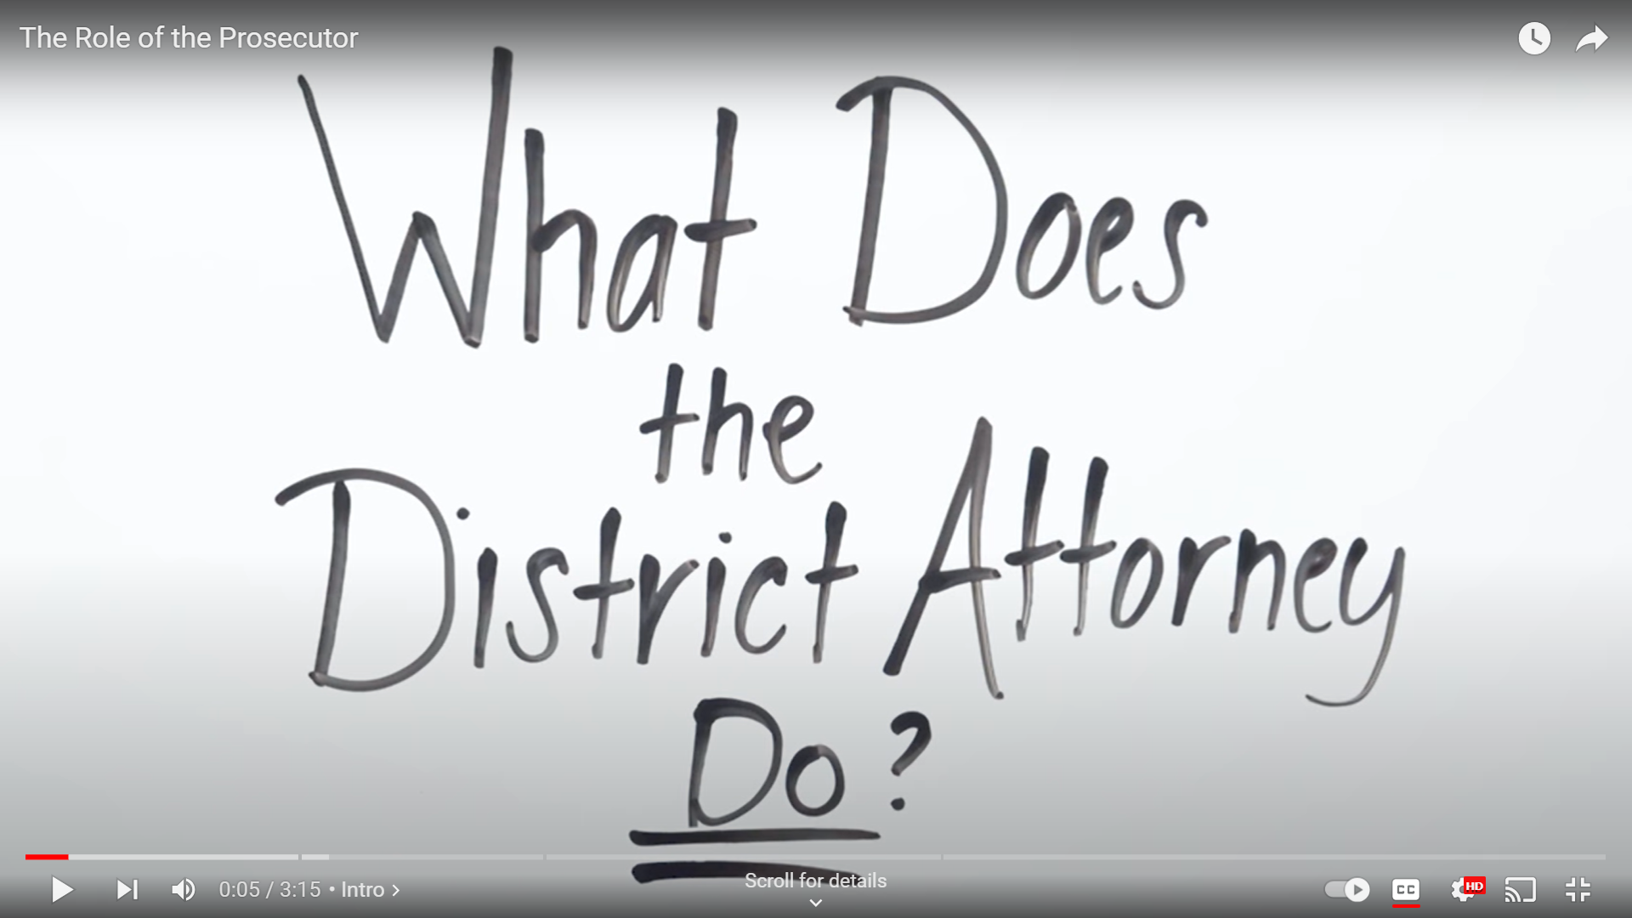

- SOCIAL MEDIA MESSAGING

Word Version | PDF Version

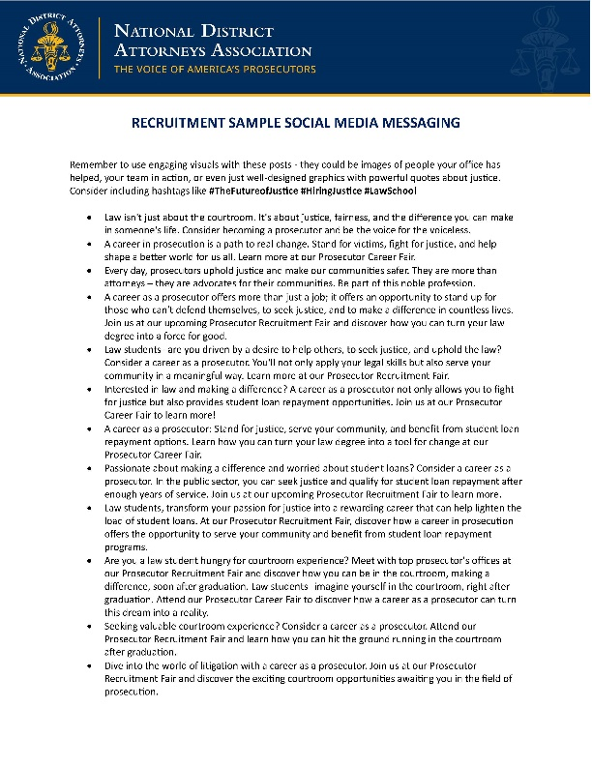

- NEWSLETTERS & EMAIL MESSAGING

Word Version | PDF Version

- PANEL DISCUSSION GUIDE TEMPLATE

Word Version | PDF Version
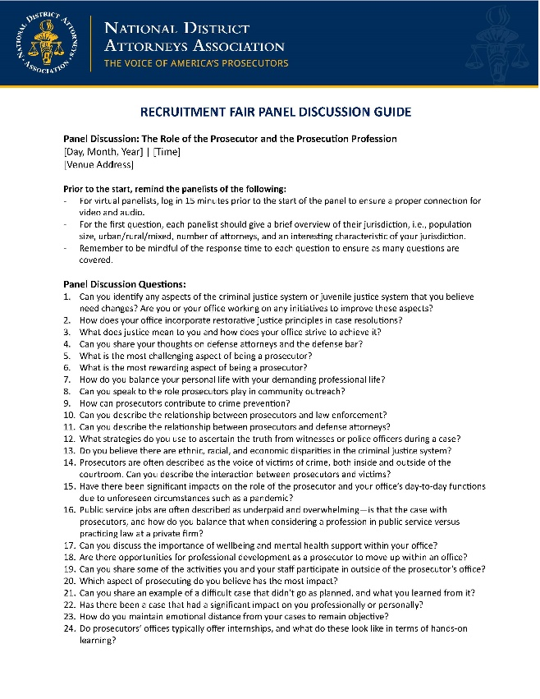

- PRESS RELEASE TEMPLATE

Word Version | PDF Version

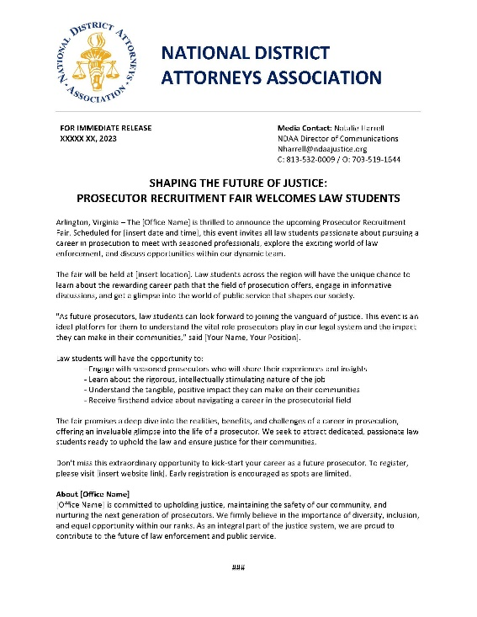

- RECRUITMENT FAIR PREPARATION AND EXECUTION CHECKLIST

Word Version | PDF Version

